Good morning Dave. Potential story? Luzerne County, thanks to Owen Costello is no stranger to the Keystone Games. A few summers back we hosted the games here in Luzerne County and had competitors from across the state. Saturday the Keystone Games hosted a statewide event for wrestling western Pa. The local competitors were from the “Altered Beast” team located on the second floor of the Martz headquarters on Old River Road S. WB. The east Pa coast competition was held prior to the state event and locals did very well. My grand daughter competed, wrestled 5 times with 5 wins, three by pins. At states she wrestled 4 times, one loss three wins two by pins. Sofia took a third place. Sofia is 14 and a Nanticoke student, in September she will be a Wyo. Sem student with the goal of wrestling for the Sem all girls’ wrestling team.
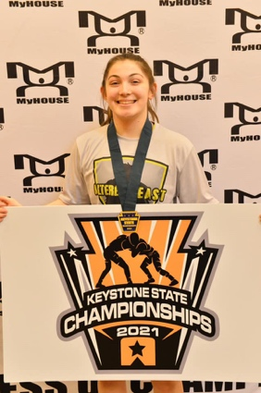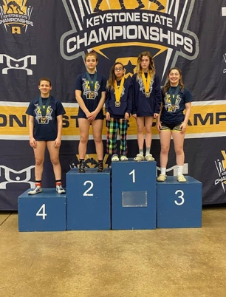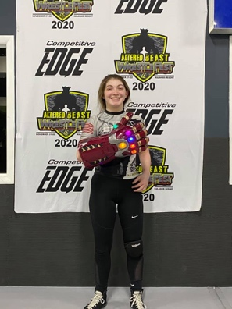Of course, I would like a feature story on my granddaughter. Her Dad, Robert Holodick and youngest daughter Norah also compete. But the main focus should be on the local team’s participation and success in the sport of grappling, Jujitsu, and wrestling. The owner/operator John Kivler is a fascinating person. I would suggest a possible interview with him and the team on site, Old River Rd. Martz Busing corporate headquarters.
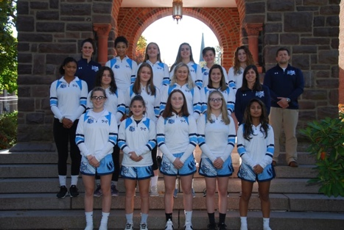Wyoming Seminary’s girls wrestling team is the only female high school wrestling program in Pennsylvania. The Sem squad is supported by USA Wrestling as an accelerated, elite development program. The team competes in Freestyle wrestling, following an international schedule and travels to the top domestic and international competitions. The 2018-19 season included trips to Japan, Austria, Sweden, and Estonia for competition and training. Hosting international teams is another big part of the Sem program. The Blue Knights hosted teams from Russia, Mongolia, Estonia, Finland, Canada, Brazil, and Japan in 2019.Head coach Erin Vandiver, who has been coaching for more than 10 years, was an Olympic team coach in 2012 (London) and 2016 (Rio). Assistant Adeline Gray has won four senior (Olympic level) world titles in that time.

Altered Beast wrestling, 237 Old River Road, Wilkes-Barre, Pa. 18702 (570) 574 7297. jrbeastsports@gmail.com
https://alteredbeastsports.sportingin.com/page/show/5969824-altered-beast-wrestling

